Modes of python

Python has two basic modes they are

1.Interactive mode

Interactive mode is a command line shell which gives immediate feedback for each statement. In interactive mode what you type is immediately run. Interactive mode allows you to test out and see what Python will do. If you ever feel the need to play with new Python statements, go into interactive mode and try them out.

To start interactive mode in windows open command prompt-> enter into python27 directory of C drive (C:\python27)->python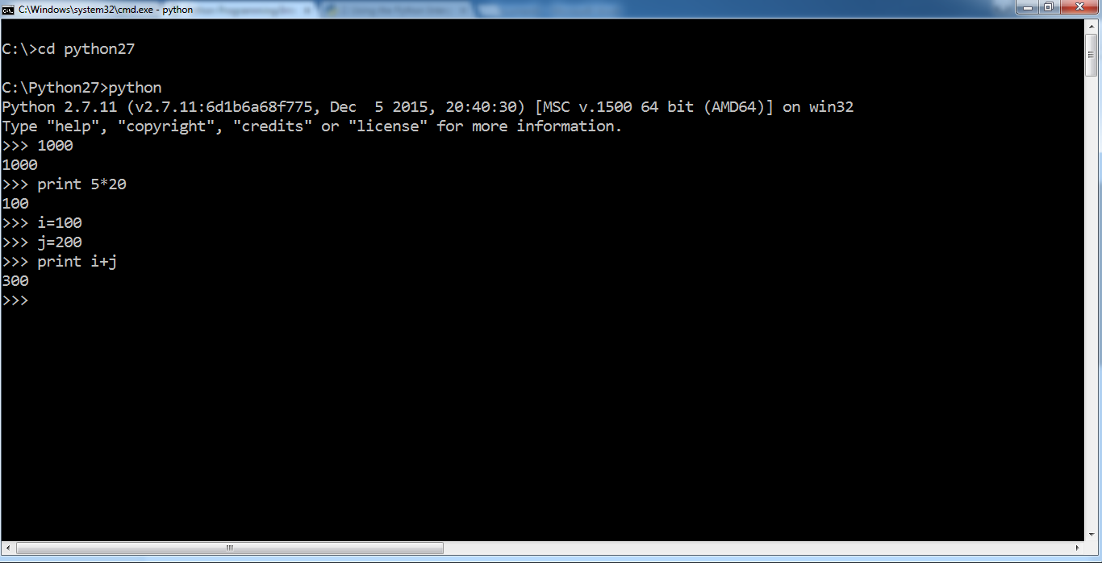

1. normal mode/batch mode

In normal mode we write the python code in editors or ide’s and save the file with extension .py

Different editors are notepad, notepad++, nano, editpuls, idle,……………

After developing the .py files in editors we submit those .py files to the python interpreter

In windows open command prompt-> enter into python27 directory of C drive (C:\python27)->

pythyon filename.py

ex: open notepad write the following code

i=1000

j=2000

print i+j

save the above file with prog1.py in C:/python27 folder

C:/python27>python test.py

Different ide’s(integrated development environment) are PyCharm,Eric,Eclipse,Netbeans,…….

After developing python applications in ide’s directly we can run python application by using short cut key